Products
– Energy Control & Management





Smart Energy Meter
PC4713-W-E-TY/3W

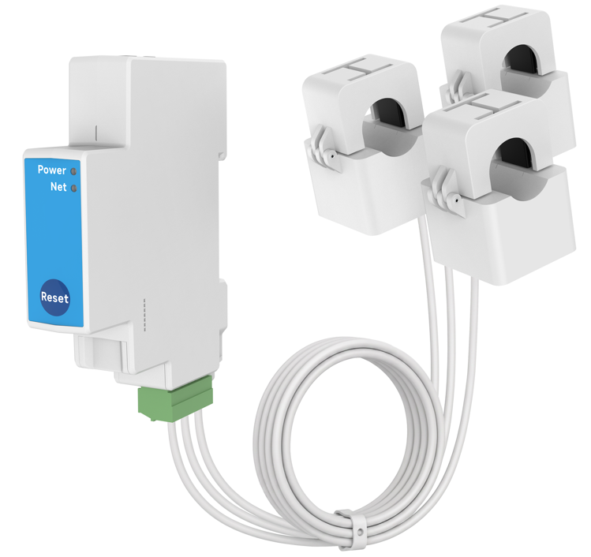

Description
PC4713-W-E-TY/3W helps you monitor the amount of electricity Consumed and Produced in your three-phase power system(included three phase three wire) by connecting the clamps on to the power cables. It is also compatible with split-phase and single-phase. It allows you to check real-time or historical energy data via mobile App.

Main Features
• Tuya compliant. Support automation with other Tuya device by export and import of grid or other energy values
• Three-Phase(included 3P3W),Split-Phase and Single-Phase electricity system compatible
• Remotely monitor whole home Energy with three current transformers
• Ethernet helps you improve the Network stability
• Real-time Voltage, Current, PowerFactor, Frequency, ActivePower, ReactivePower, ApparentPower measurement
• Bidirectional measurement: Energy Usage / Solar Production
• Historical data could be displayed in Day, Week, Month and Year

Main Specifications


Connectivity
Wi-Fi | • 802.11 b/g/n @2.4GHz
BLE | • For Pairing
Ethernet | • 10/100 Mbps
Physical Specifications
Operating Voltage | • L-N：90~277 Vac 50/60Hz  • L-L：156~480 Vac 50/60Hz
Supported Systems | • Single-Phase  • Split-Phase  • Three-Phase （included 3-Phase, 3-Wire）
Voltmeters Accuracy | • ±1%
Ammeters Accuracy | • 80A CT: ±1%（1-80A），±2%（0-1A）  • 120A CT: ±1%（2-120A），±2%（0-2A）  • 200A CT: ±1%（2-200A），±2%（0-2A）  • 300A CT: ±1%（6-300A），±2%（2-6A），±5%（0-2A）  • 500A CT: ±1%（6-500A），±2%（2-6A），±5%（0-2A）  • 750A CT: ±1%（6-750A），±2%（2-6A），±5%（0-2A）
Clamp Inner  Dimension | • 80A (default): Ø10mm  • 120A(optional): Ø16mm  • 200A(optional): Ø20mm  • 300A(optional): Ø24mm  • 500A(optional): Ø36mm  • 750A(optional): Ø51mm
Reporting Cycle | • 15 seconds
Operating Environment | • Temperature: -20 ℃~+55 ℃  • Humidity: ≤ 90% non-condensing
Mount Type | • 35mm DIN rail mounting
Dimension | • 19(W) x 69(D) x 90(H)mm
Certification | •CE

